Lab 4 Furnace Controller Logic With VHDL

XXXXXX

August 9, 2005

EET207 Steen Larsen

Introduction

Purpose of the Experiment
The purpose of this lab is to design the logic to control a gas operated forced-air furnace. The circuit will be emulated with VHDL.

Method

General/Standard Method Used
A truth table and Karnaugh map were used to determine the Boolean equation in SOP form. The schematic was designed to implement the Boolean equation. A VHDL file was written (furnace.vhd) and compiled to emulate the circuit and Boolean equation using the Altera Quartus II application. A simulation wave file was created to test the VHDL code output. This was accomplished by creating a timing diagram which represented the circuit’s truth table. This verified all truth table inputs (H,W,T) and outputs (G,F). This experiment is derived from Lab 6 of Experiments in Digital Electronics by Gary Hecht, which is the lab book used for Portland Community College’s EET178.

Instruments
Arrow Electronics Development Board for Altera MAX 3000A CPLD (EPM3128ATC100-10)

Software
Altera Quartus II version 5.0

Experimental Results

Part 1: Truth Table/Karnaugh Map/Boolean Equation

The following conditions were defined:

Inputs:
- T is 0 when the house is warm enough (above setpoint temperature).
- T is 1 when the house needs heat (below setpoint temperature).

- W is 0 when the furnace air box is not warm.
- W is 1 when the furnace air box is warm.

- H is 0 when the furnace is not overheated.
- H is 1 when the furnace is overheated.

Output:
- G is 0 when the gas valve is turned off (not heating the house).
- G is 1 when the gas valve is turned on (heating the house).

- F is 0 when the air circulation fan is off.
- F is 1 when the air circulation fan is turned on.

Functional requirements:
- When the thermostat reports the house temperature is below the setpoint temperature, the furnace controller should turn on the gas valve and keep it on until the thermostat reports the house temperature is above the setpoint temperature.

- When the thermostat reports the house is both below the setpoint temperature and the air box is warm, the furnace controller turns on the fan and keeps it on until the thermostat reports the house temperature is both above the setpoint temperature and the air box is not warm.

- If the furnace is ever overheated, the furnace will turn the gas valve off and the fan on to help carry heat away from the overheated furnace.

Based on the defined conditions, the following truth table was rendered:

H | W | T | G | F
0 | 0 | 0 | 0 | 0
0 | 0 | 1 | 1 | 0
0 | 1 | 0 | 0 | 1
0 | 1 | 1 | 1 | 1
1 | 0 | 0 | 0 | 1
1 | 0 | 1 | 0 | 1
1 | 1 | 0 | 0 | 1
1 | 1 | 1 | 0 | 1

Based on the truth table, the following Karnaugh maps were rendered:
Gas Fan
 | T |  |  |  | T
HW | 0 | 1 |  | HW | 0 | 1
00 |  | 1 |  | 00
01 |  | 1 |  | 01 | 1 | 1
11 |  |  |  | 11 | 1 | 1
10 |  |  |  | 10 | 1 | 1

Based on the Karnaugh maps, the following Boolean equations were rendered:
- G = TH’
- F = W + H = (W’H’)’

Part 2: Circuit Design

Based on the Boolean equations, the following circuit was designed (minus pull-up resistors and switches):

Part 3: VHDL Coding

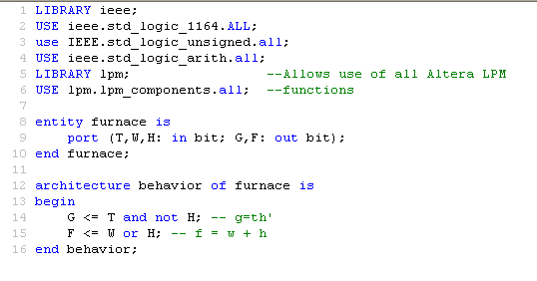The VHDL emulation of the furnace circuit is a follows (compiled with 0 errors and 0 warnings):
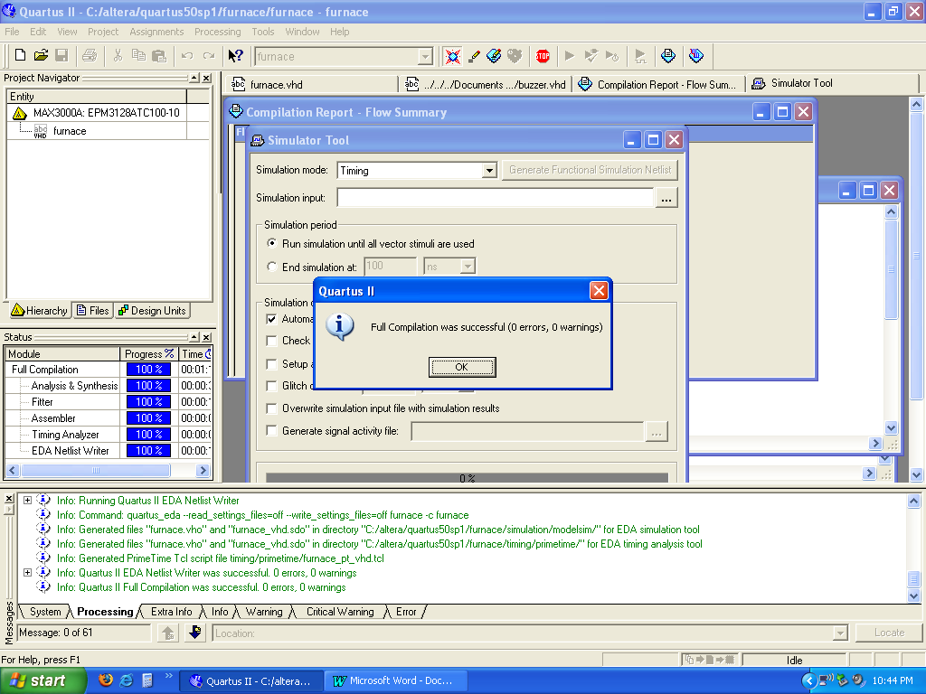

Part 4: VHDL Simulation

The following VHDL simulation wave file was used. This timing diagram simulates the truth table. The simulation completed with 0 error and 0 warnings:
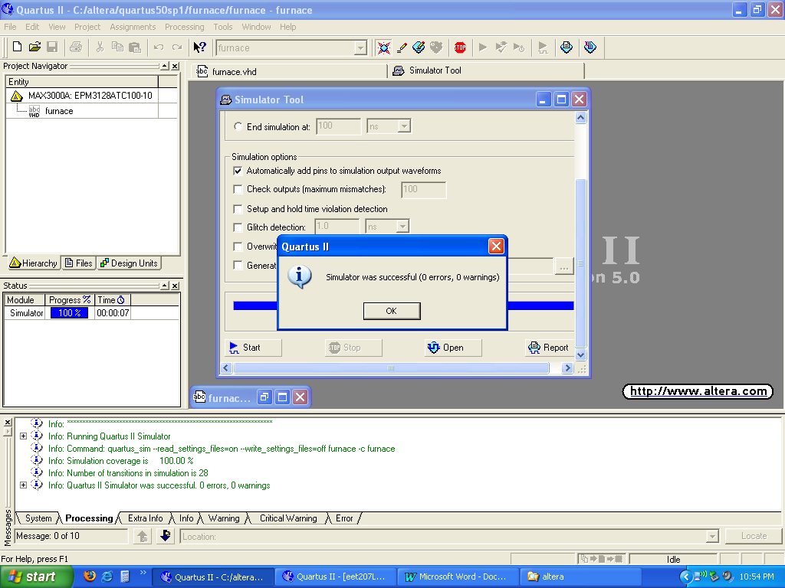

Part 5: VHDL Download Into Altera Board

After the VHDL code was compiled and simulated, the resulting code was downloaded into the altera board and tested. The following pin assignments were used, which represented :

T PIN_24 (SW1)
W PIN_27 (SW2)
H PIN_28 (SW3)
G PIN_70 (SegA of 7 Segment Display)
F PIN_71 (SegB of 7 Segment Display)

A combination of SW1, SW2, SW3 were pressed to simulate the truth table to verify the compiled VHDL code as downloaded onto the Altera board.

Conclusion

A furnace was simulated using the methods learned in EET207 and VHDL. Defined conditions were used to construct the truth table, the truth table was used to construct a Karnaugh map, which was then used to determine the Boolean Equation. The Altera Quartus II software was much easier to set up in Lab4 than in Lab3. This real world situation did verify the underlying theory that this lab used to build the furnace controller.

